Question Examples:

How Does Self-Regulation Affect Computer-Programming Achievement in a Blended Context?
- (Cigdem, 2015)
- Assessments broken into categories (scaled 1 to 5: strongly disagree to strongly agree):
  - Blended learning
  - Self-regulated learning
  - Perceived self-efficacy
    - “I feel confident using…”
  - Perceived anxiety
    - “… makes me feel anxious”
  - Interactivity in the Online Learning Environment
  - Perceived satisfaction
  - Perceived usefulness
    - “I believe … is useful for learning”
- Notes:
  - Study only looked at males
  - Suggests taking age into account

Student perceptions towards introductory lessons in R
- (Custer et al., 2021)
- Did quantitative measures AND qualitative measures
  - How would you rate your familiarity with R? (1 being very unlikely; 5 being very likely)
  - How likely would you be to use R to analyze data if asked to do so today? (1 being very unlikely; 5 being very likely)
  - Providing as much detail as you can, please describe how you would produce a graph for a lab report or presentation if asked to do so today?
  - What challenges do you feel stand in your way for learning R?
  - What benefits do you see coming from using R or other programming languages?

Data Science in Undergraduate Life Science Education: A Need for Instructor Skills Training
- (Emery et al., 2021)
- Surveyed instructor skills
  - Degree
  - Year in school
  - Major

Teaching data science to students in biology using R, RStudio and Learnr: Analysis of three years data
- (Engels et al., 2023)
- Did a Likert-scaled test but didn’t post questions anywhere
- Used NASA task load index to assess workload
  - https://humansystems.arc.nasa.gov/groups/tlx/downloads/TLXScale.pdf
    - Mental demand (very low to very high)
    - Physical demand
    - Temporal demand
    - Performance demand
    - Effort
    - Frustration (How insecure, discouraged, irritated, stressed, and annoyed were you?)

Undergraduate R Programming Anxiety in Ecology: Persistent Gender Gaps and Coping Strategies
- Gender
- Race
- Additional information
  - First generation
  - Nontraditional
  - Learning disability, not registered
  - Learning disability, registered
- Anxiety in R
- Sense of control in R

Teaching Undergraduates R in an Introductory Research Methods Course: A Step-by-Step Approach
- (Li, 2021)
- Student assessment of R skills
  - No R skills
  - Some R skills
  - Good R skills
  - Very good R skills
  - Exceptional R skills
- Student perception of R use in job search
  - Not at all helpful, not very helpful, somewhat helpful, very helpful, extremely helpful
- Student assessment of difficulty learning R
  - Very difficult, difficult, neither easy nor difficult, easy, very easy
- Student comfort asking help from classmates
  - Not at all comfortable, not very comfortable, comfortable, very comfortable, extremely comfortable
- Student comfort getting help from the internet
  - Not at all comfortable, not very comfortable, comfortable, very comfortable, extremely comfortable

Components:
- Demographics (at time of survey)
- Anxiety (pre- and post-)
  - Gaining initial skills
  - Sense of control
  - R self-concept
  - State of anxiety
- Self-evaluated engagement in class and online materials (all around)
- Coping (all around)
- Metrics surrounding R skills and comfortability before and after class (pre- and post-)
  - Maybe break up by skill? Plotting? For loops?

- Sante Fe New Mexico complex systems fellowship situation
- Slimming down questionnaires?
- Names?
- Anxiety surrounding math versus computer programming?
  - Ask same anxiety question for both
- Surveys for dummies kind of resource for resource basics
  - Send Miguel a good one

QUESTION BANK:
BASICS
- Name
- Degree you are pursuing (Serão et al., 2021)
- Current academic standing (freshman, etc.) (Li, 2021)
- Age (Forrester et al., 2022; Serão et al., 2021)
- Gender (Forrester et al., 2022)
- Race (Forrester et al., 2022)
- Transfer students?
- How old laptop is?
- First generation, nontraditional, learning disability (not registered), learning disability (registered) (Forrester et al., 2022)

QUANTITATIVE
- How would you rate your familiarity with R? (Custer et al., 2021)
  - 1 being not familiar; 5 being highly familiar
- How likely would you be to use R to analyze data if asked to do so today? (Custer et al., 2021)
  - 1 being very unlikely; 5 being very likely
- Do you know how to use Microsoft Excel? (Likert) (Li, 2021)
- Evaluate your knowledge on any other computing language (e.g., Python, SAS, SPSS, MATLAB, JMP, etc.) (Serão et al., 2021)
- On a scale of 1 to 5 with 1 being not interested and 5 being very interested, how interested are you in taking a class with high/moderate/low quantitative content? (Uttl et al., 2013)
- On a scale of 1 to 5, 1 being “I have no R skills”, 3 “I have good R skills”, and 5 “I have exceptional R skills,” what do you think about your R coding skills?
- On a scale of 1 to 5, 1 being “not at all helpful”, 3 “somewhat helpful”, and 5 “extremely helpful,” to what degree do you think your R coding skills will be helpful in your future job search? (Li, 2021)
- On a scale of 1 to 5, 1 being “very difficult”, 3 “neither easy nor difficult”, and 5 “very easy,” what do you think about your learning experience with R? (Li, 2021)
- On a scale of 1 to 5, 1 being “not at all comfortable”, 3 “somewhat comfortable”, and 5 “extremely comfortable,” how comfortable do you feel in terms of finding R help from your classmates? (Li, 2021)
- On a scale of 1 to 5, 1 being “not at all comfortable”, 3 “somewhat comfortable”, and 5 “extremely comfortable,” how comfortable do you feel in terms of finding R help (e.g. websites, YouTube videos) from the internet? (Li, 2021)

To Measure Perceived Task Load of the Class (all Likert)
- How mentally demanding was the [class]? (Engels et al., 2023; Hart & Staveland, 1988)
- How physically demanding was the [class]? (Engels et al., 2023; Hart & Staveland, 1988)
- How hurried or rushed was the pace of the [class]? (Engels et al., 2023; Hart & Staveland, 1988)
- How successful were you in accomplishing what you were asked to do? (Engels et al., 2023; Hart & Staveland, 1988)
- How hard did you have to work to accomplish your level of performance? (Engels et al., 2023; Hart & Staveland, 1988)
- How insecure/discouraged/irritated/stressed/annoyed were you? (Engels et al., 2023; Hart & Staveland, 1988)

To Measure Anxiety (Connolly et al., 2009; Forrester et al., 2022)
Gaining Initial Computer Skills (indicate the extent to which each of the following situations described would make you anxious; 1-not at all, 2-a little, 3-a fair amount, 4-much, 5-very much)
- Collaborating with a friend while learning to use a computer
- Being evaluated on my computer competence
- Taking a course in a computer language
- Learning computer terminology
Sense of Control (indicate how often you have the following thoughts when you use a computer or think about using a computer; 1-very much, 2-much, 3-a fair amount, 4-a little, 5-not at all) **NOTICE THE FLIPPED ANSWERS
- I know I can do it.
- I feel in control of what I do.
- In class, everyone else but me knows what they’re doing.
Computer Self Concept (using the following scale, please indicate how much you agree or disagree with the following propositions; 1-strongly agree, 2-agree, 3-unsure, 4-disagree, 5-strongly disagree)
- Anyone can learn computers if they are patient and motivated.
- I can get good grades in computer courses.
- I don’t think I would be able to learn a computer programming language.
- I don’t think I will/could handle a computer course.
State of Anxiety in Computer Situations (using the following scale, indicate how often you have the following feelings or symptoms when you use a computer, think about using a computer or having to write a computer program; 1-almost never, 2-sometimes, 3-often, 4-almost always) *** Notice 4 answers instead of 5
- I feel anxious whenever I am using computers.
- I feel at ease with computers.
- Hot and sweaty.
- Lack of concentration

R Anxiety from Forrester Questionnaire (Connolly et al., 2009; Forrester et al., 2022)
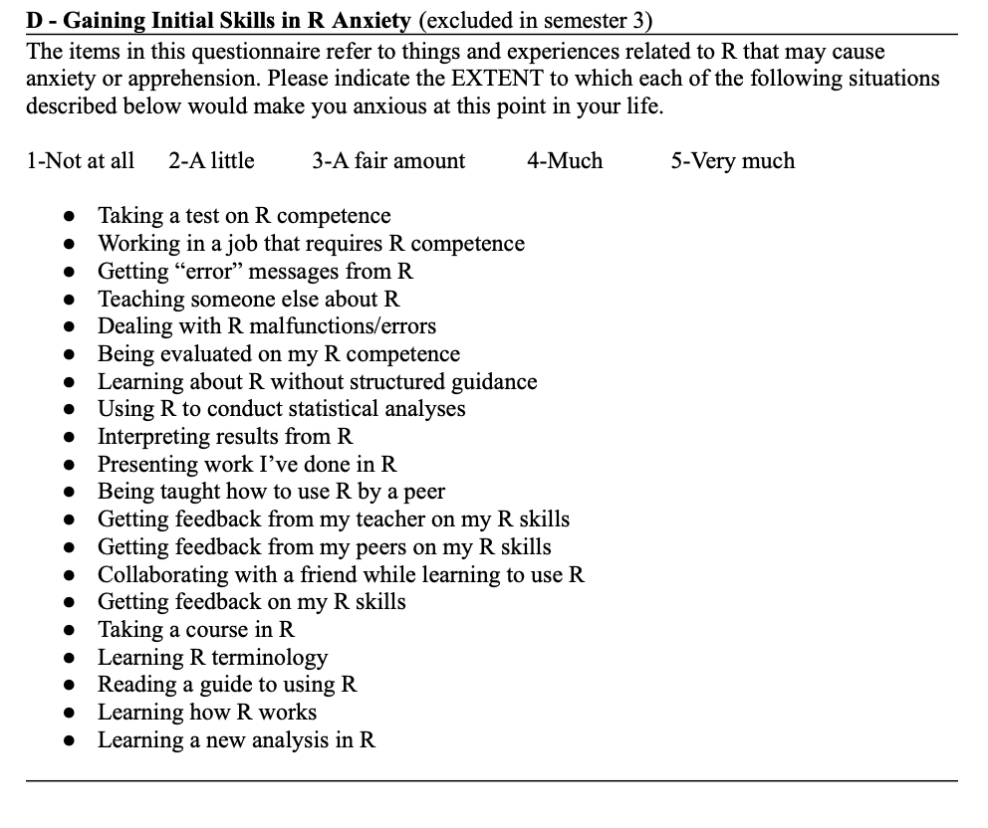
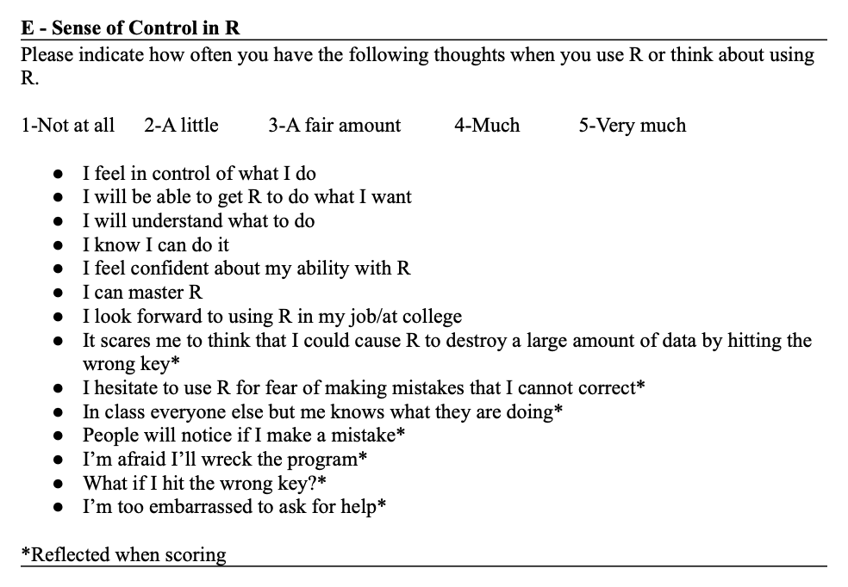
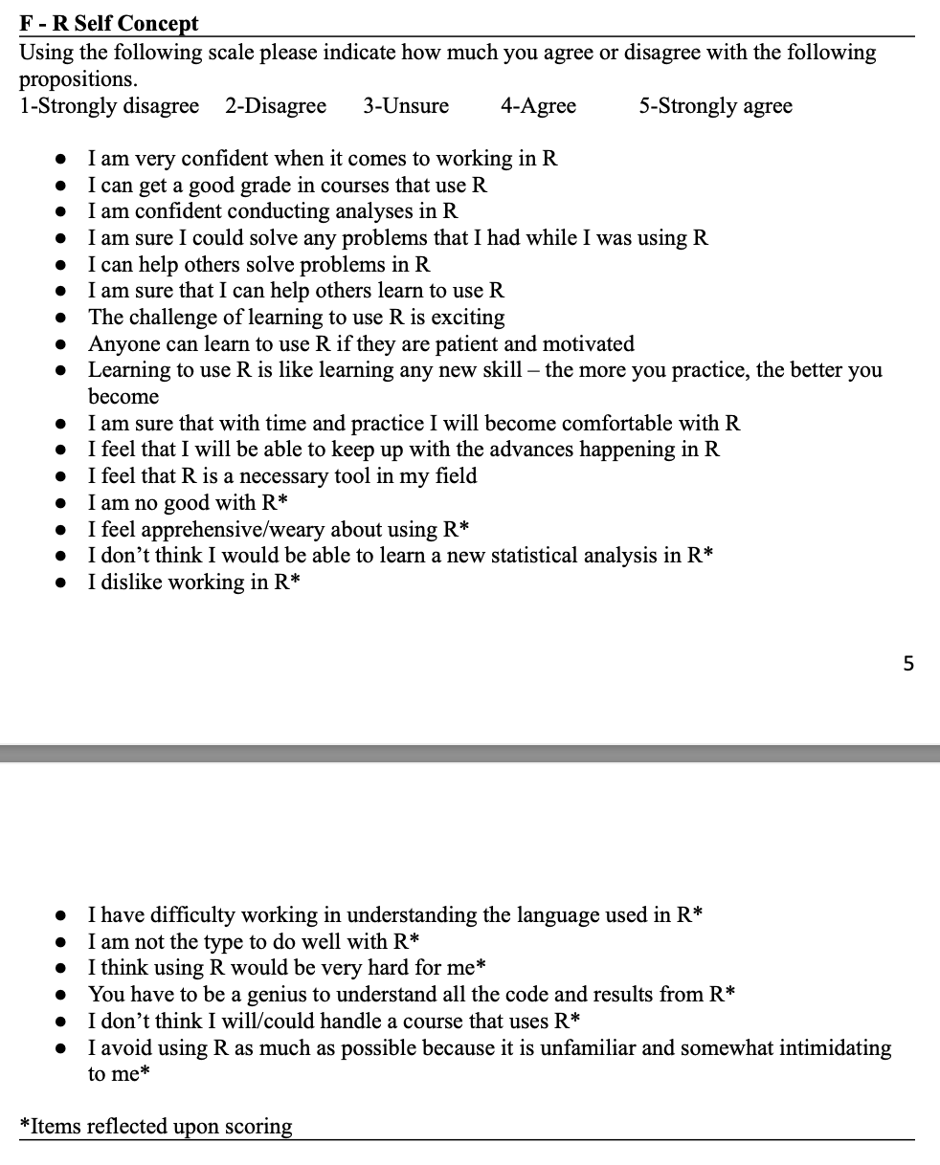
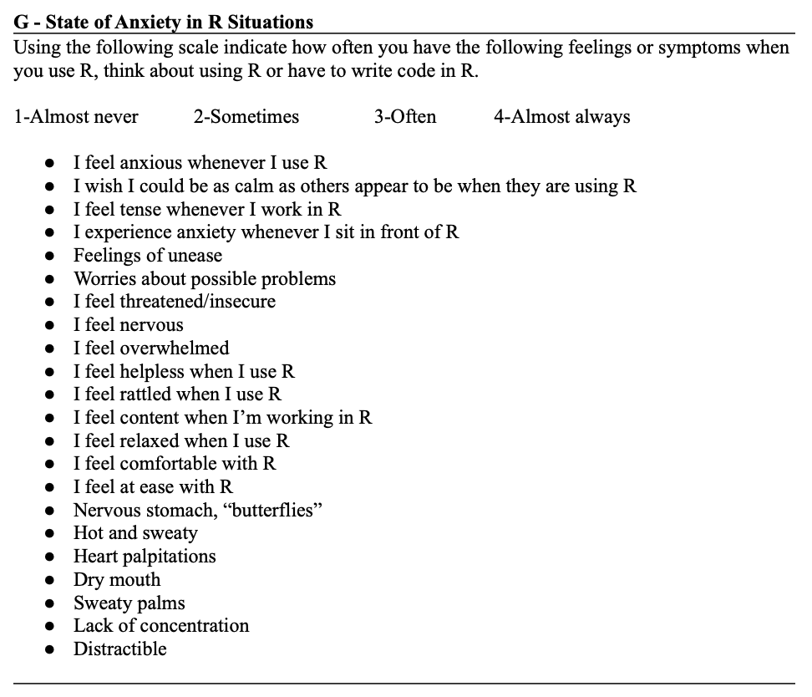

Coping skills from Forrester Questionnaire
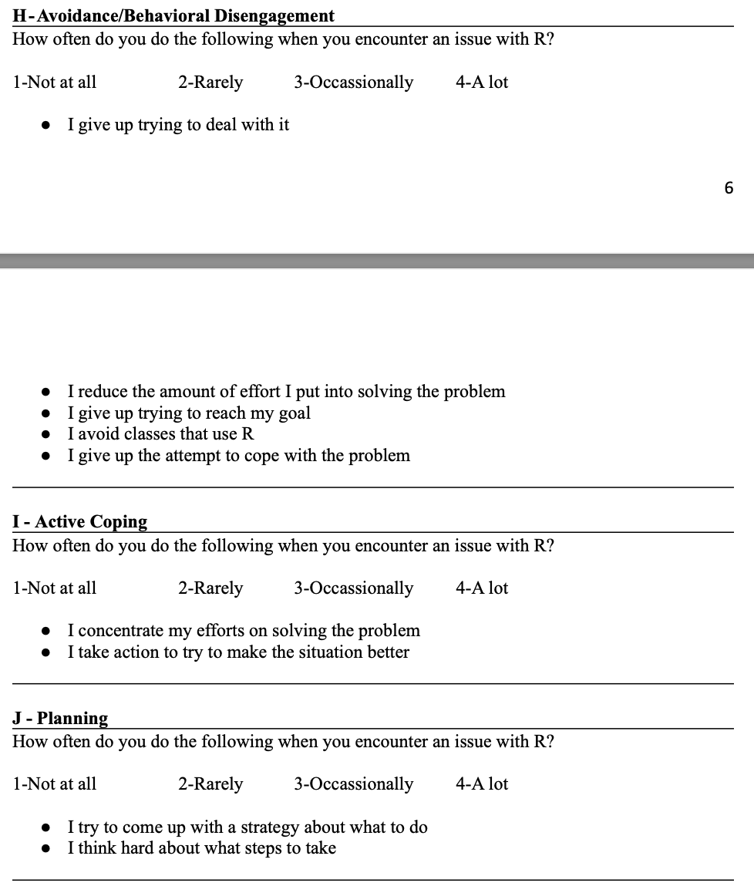
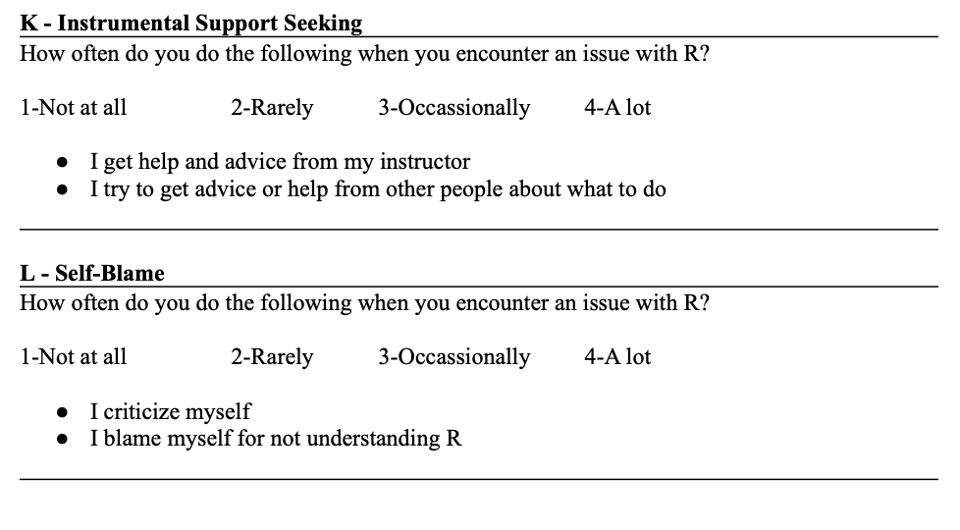

QUALITATIVE
- Providing as much detail as you can, please describe how you would produce a graph for a lab report or presentation if asked to do so today? (Custer et al., 2021)
- What challenges do you feel stand in your way for learning R? (Custer et al., 2021)
- What benefits do you see coming from using R or other programming languages? (Custer et al., 2021)

? Student self-evaluated engagement

